Expression of Interest

Rooff are actively seeking to strengthen their supply chain with NEW subcontract companies.

We work in the Greater London Areas and carry out a wide range of construction projects such as Commercial, Residential, Refurbishment, Education, Health and Community, Recreation, Religious and Historical Buildings, special one-off commissions and development.

If you are interested in working as a subcontractor for us please complete this form and return to kkalula@rooff.co.uk

Company Name

Company Address

Trade

Areas Worked

Contact Name

Contact Number

Contact Email

How did you hear about us?

Once this information is received we will send you out a questionnaire and invite you to one of our Meet the Buyer events.

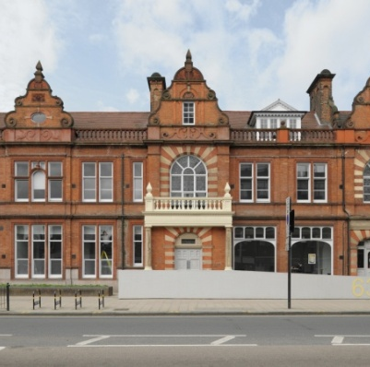
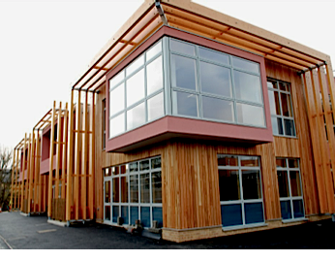
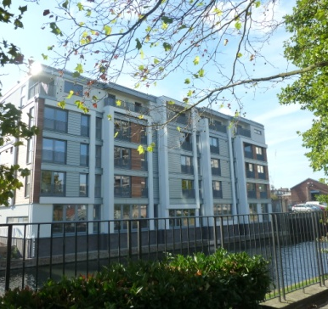
Tottenham High Road, N17
Ben Jonson Primary School, E1
Branch Place, N1

Rooff
The Granary, 80 Abbey Road, Barking, London IG11 7BT
t. 020 8709 1777 w. rooff.co.uk

